- Remove the top cover the recovery tank to get access to the red plug.
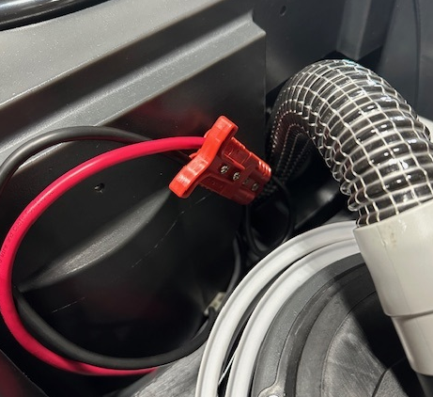

- Pull on the red handle to disconnect the battery pack from the machine.
- The end of the plug that is mounted to the tank leads to the control panel. Do not hook the charger to this plug.
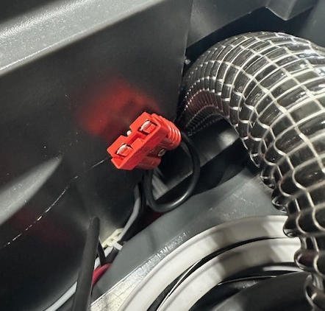
Do not plug charger here

- The end with the handle leads to the battery pack. You will see a green line on each side of the plug.
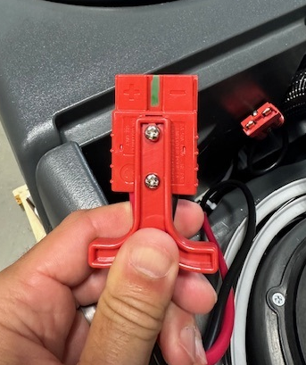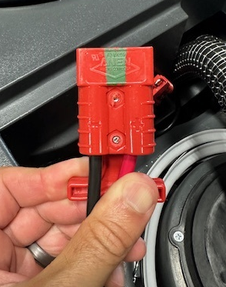
- Ensure that the charger being used has a green “QC Approved” sticker on it.
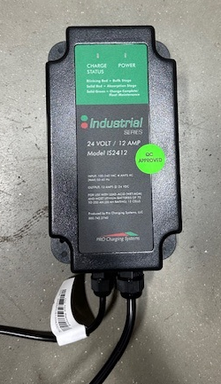

- The red plug on the charger has the same 2 green lines as the connector that goes to the battery pack.
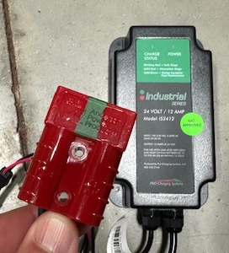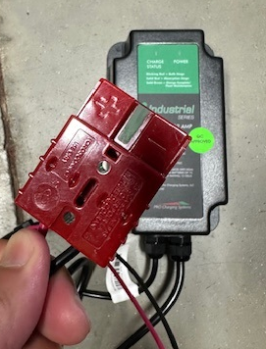

- Plug the charger into the battery connector. Ensure the two connectors with the green lines are what you connect. Remember: Green to Green.
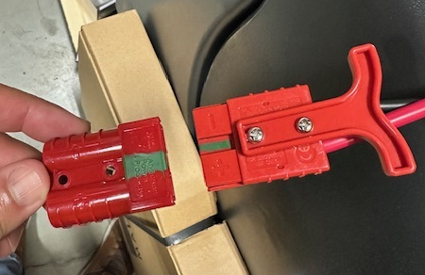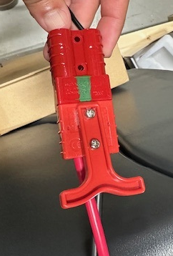

- The charging cycle will now begin.

